 **OUTREACH SCHOOLS EXAMINATIONS BOARD**

**END OF TERM I EXAMINATION 2024**

**P.7 SCIENCE**

***Time Allowed: 2hours 30 Minutes***

|  |  |  |  |  |  |  |  |  |
| --- | --- | --- | --- | --- | --- | --- | --- | --- |
| Random No. | | | | | | Personal No. | | |
|  |  |  |  |  |  |  |  |  |

**Candidate’s Name: …………………………………………………………………..…**

**Candidate’s Signature: ……………………………………..…………………………**

**School Name: ……………………………………………..……………………………..**

**District No:**

**SECTION A**

**INSTRUCTIONS:**

1. Answer all questions. **SECTION B**

2. Any drawing must be done in pencil. **TOTAL**

3. Use a very good handwriting.

**SECTION A (40 marks)**

1. What do we call the frame work of bones in the human body?

…………………………………………………………………………………………..……………………………………………..

1. State any one importance of bathing to P.7 candidates.

…………………………………………………………………………………………..……………………………………………..

1. Mr. Opeto the science teacher encourages his students always to check on the expiry date of drugs before taking them. How is this important?

…………………………………………………………………………………………..……………………………………………..

1. What are invertebrates?

…………………………………………………………………………………………..……………………………………………..

1. Name the disease spread by tsetse flies to people.

…………………………………………………………………………………………..……………………………………………..

1. Identify the human health condition whose first aid is tepid sponging.

…………………………………………………………………………………………..……………………………………………..

1. Give one advantage of using electricity as a source of fuel other than firewood.

…………………………………………………………………………………………..……………………………………………..

1. Mention the pollination agent of the flowers that are scented.

…………………………………………………………………………………………..……………………………………………..

1. How is the breathing of a housefly different from that of a spider

…………………………………………………………………………………………..……………………………………………..

1. Which bone(s) of the human body protects the spinal cord?

…………………………………………………………………………………………..……………………………………………..

1. Condoms are used to control the spread of STDs. Give one other use of condoms.

…………………………………………………………………………………………..……………………………………………..

1. Suggest one way by which P.7 pupils can control the spread of ringworm at school.

…………………………………………………………………………………………..……………………………………………..

1. Suggest one way harvested sorghum can be prevented.

…………………………………………………………………………………………..……………………………………………..

1. Mention any one natural source of sound energy.

…………………………………………………………………………………………..……………………………………………..

Use the diagram below to answer question 15 and 16.

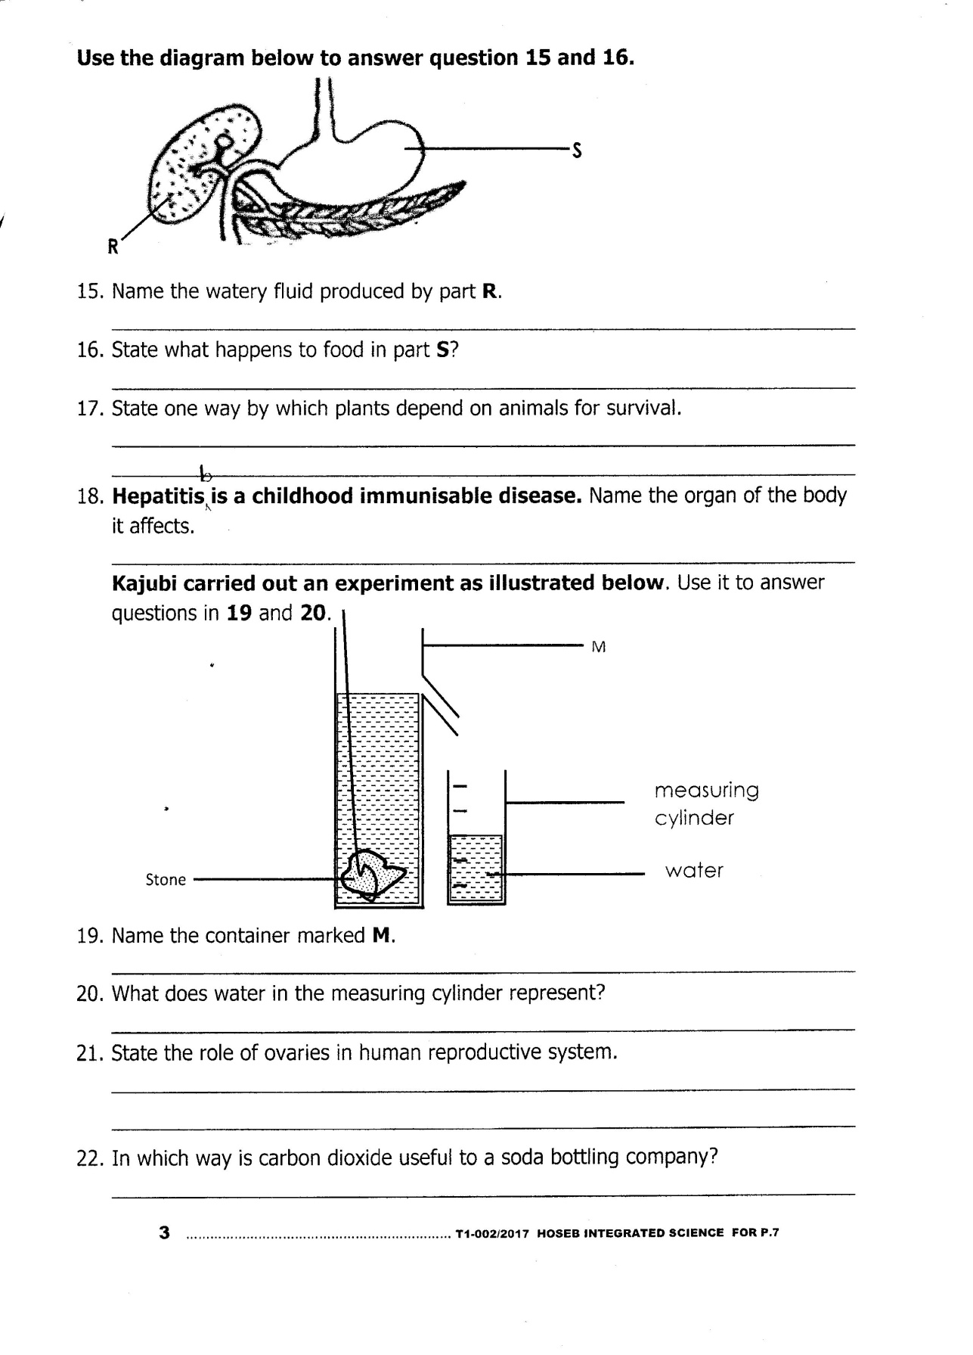

1. Name the watery fluid produce by part R.

…………………………………………………………………………………………..……………………………………………..

1. State what happens to food in part S?

…………………………………………………………………………………………..……………………………………………..

1. State one way by which plants depend on animals for survival.

…………………………………………………………………………………………..……………………………………………..

1. Hepatitis B is a childhood immunisable disease. Name the organ of the body it affects.

…………………………………………………………………………………………..……………………………………………..

Kajubi carried out an experiment as illustrated below. Use it to answer questions 19 and 20.

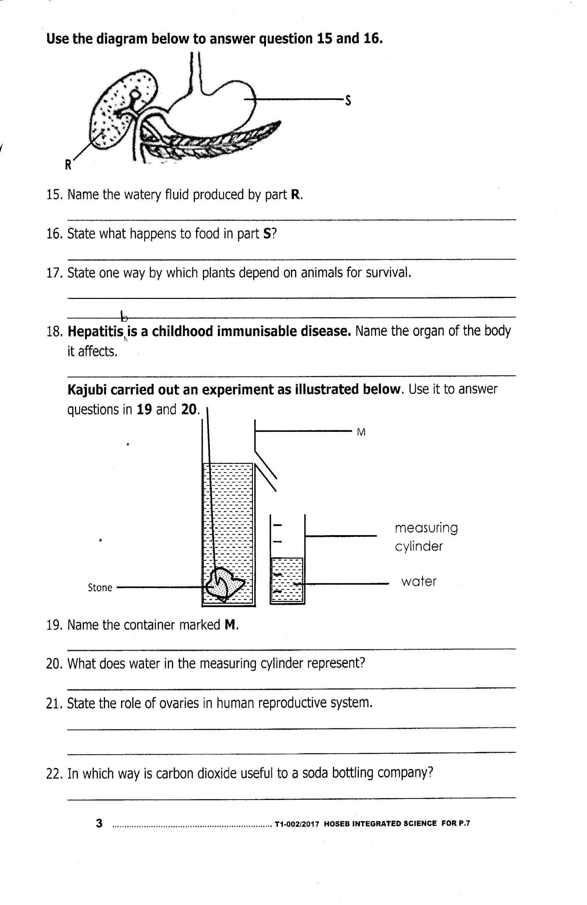

1. Name the container marked M.

…………………………………………………………………………………………..……………………………………………..

1. What does water in the measuring cylinder represent?

…………………………………………………………………………………………..……………………………………………..

1. State the role of ovaries in human reproductive system.

…………………………………………………………………………………………..……………………………………………..

1. In which way is carbon dioxide useful to a soda bottling company?

…………………………………………………………………………………………..……………………………………………..

1. Suggest one way friction can be increased on a road surface.

…………………………………………………………………………………………..……………………………………………..

1. Name the magnet pole marked T in the diagram below.

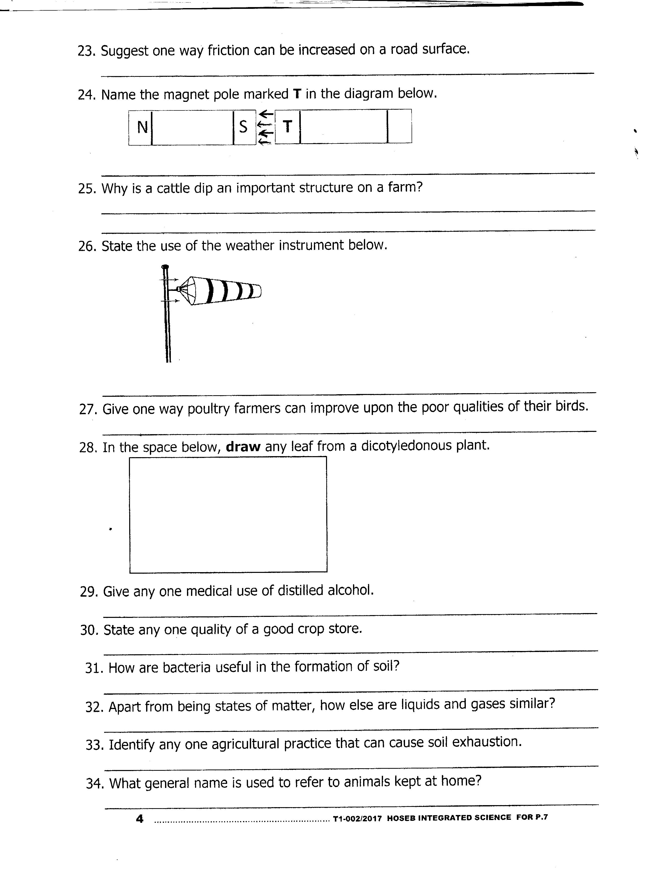

…………………………………………………………………………………………..……………………………………………..

1. Why is a cattle did an important structure on a farm?

…………………………………………………………………………………………..……………………………………………..

1. State the use of the weather instrument below.

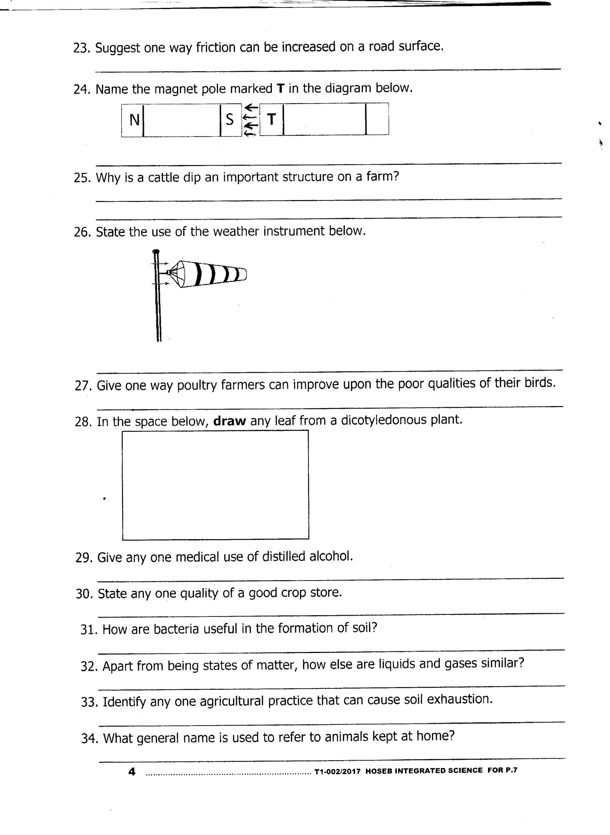

…………………………………………………………………………………………..……………………………………………..

1. Give one way poultry farmers can improve upon the poor qualities of their birds.

…………………………………………………………………………………………..……………………………………………..

1. In the space below, draw any leaf from a dicotyledonous plant.
2. Give any one medical use of distilled alcohol.

…………………………………………………………………………………………..……………………………………………..

1. State any one quality of a good crop store.

…………………………………………………………………………………………..……………………………………………..

1. How are bacteria useful in the formation of soil?

…………………………………………………………………………………………..……………………………………………..

1. Apart from being states of matter, how else are liquids and gases similar?

…………………………………………………………………………………………..……………………………………………..

1. Identify any one agricultural practice that can cause soil exhaustion.

…………………………………………………………………………………………..……………………………………………..

1. What general name is used to refer to animals kept at home?

…………………………………………………………………………………………..……………………………………………..

1. The head teacher of Katwe Primary School gave a good speech in parents’ meeting. How could his speech be kept for future reference?

…………………………………………………………………………………………..……………………………………………..

1. If one dry cell has 1.5 volts, find the total voltage for 3 dry cells.
2. Apart from providing shade and acting as a wind break, how else are trees planted around a factory important?

…………………………………………………………………………………………..……………………………………………..

1. Name one mineral that is required for the formation of bones in the human body.

…………………………………………………………………………………………..……………………………………………..

1. State any one importance of sheep rearing to people.

…………………………………………………………………………………………..……………………………………………..

1. To which group of vertebrates does a Tilapia belong?

…………………………………………………………………………………………..……………………………………………..

**SECTION B (60 marks)**

1. a) What is germination?

…………………………………………………………………………………………..……………………………………………..

b) Mention any one condition necessary for a seed to germinate.

…………………………………………………………………………………………..……………………………………………..

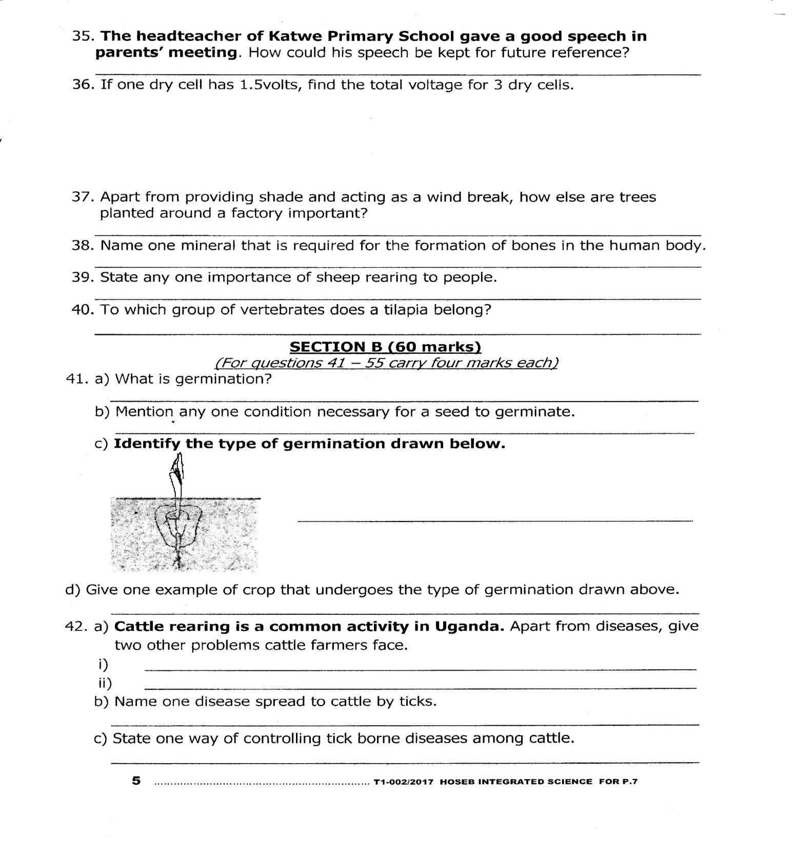c) Identify the type of germination drawn below.

………………………………………………………………………………………………..…………..

d) Give one example of crop that undergoes the type of germination drawn above.

…………………………………………………………………………………………..……………………………………………..

1. a) Cattle rearing is a common activity in Uganda. Apart from diseases, give two other problems cattle farmers face.

i) …………………………………………………………. ii) …………………………………………….…………………………

b) Name one disease spread to cattle by ticks.

…………………………………………………………………………………………..……………………………………………..

c) State one way of controlling tick borne diseases among cattle.

…………………………………………………………………………………………..……………………………………………..

1. a) Outline any two components of air.
2. …………………………………………….…………….. ii) ………………………………………………………………

b) State any one property of air.

…………………………………………………………………………………………..……………………………………………..

c) Give any one use of air to people.

…………………………………………………………………………………………..……………………………………………..

1. **Below is a diagram of a human joint. Use it to answer the given questions.**

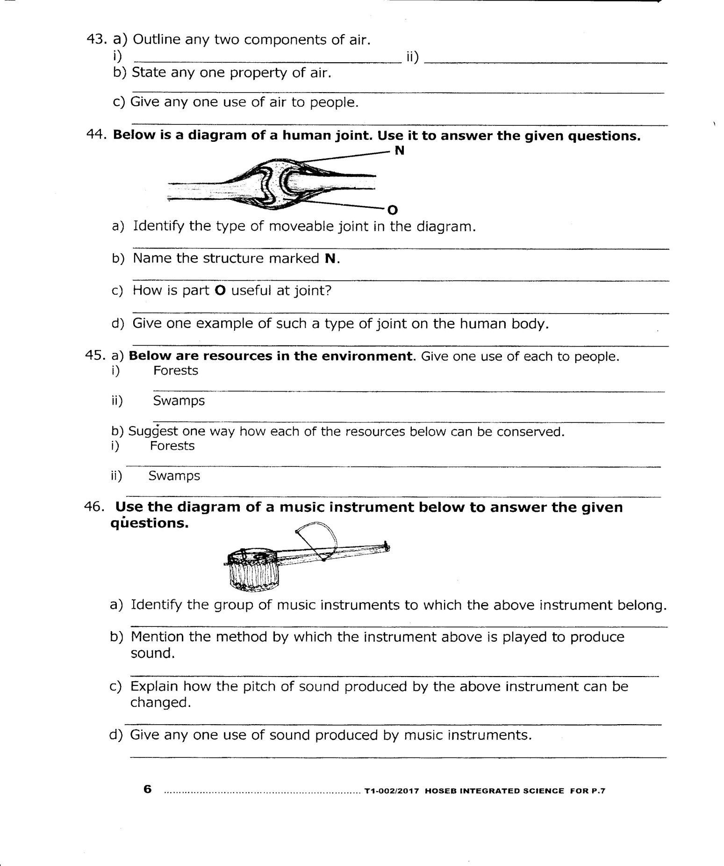

1. Identify the type of moveable joint in the diagram.

………………………………………………………………………………………..……………………………………………..

1. Name the structure marked N.

………………………………………………………………………………………..……………………………………………..

1. How is part O useful at joint?

………………………………………………………………………………………..……………………………………………..

1. Give one example of such a type of joint on the human body.

………………………………………………………………………………………..……………………………………………..

1. a) Below are resources in the environment. Give one use of each to people.
2. Forest ………………………………………………………………………………………………………………………..
3. Swamps ……………………………………………………………………………………………………………………..

b) Suggest one way how each of the resources below can be conserved.

i) Forests ………………………………………………………………………..……………………………………………..

ii) Swamps ……………………………………………………………………..……………………………………………..

1. 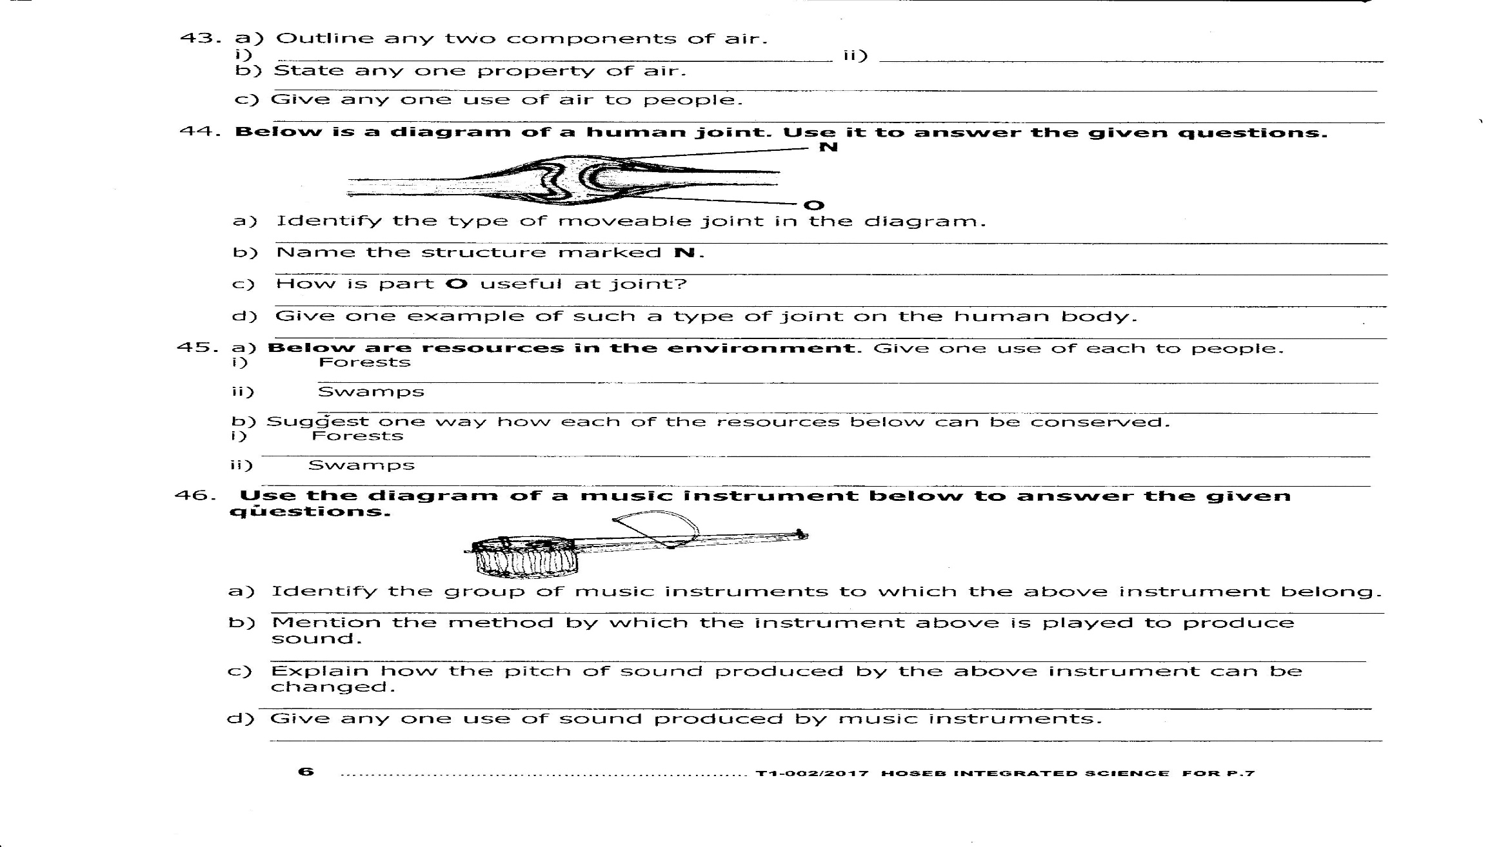Use the diagram of a music instrument below to answer the given questions.

a) Identify the groups of music instruments to which the above instrument belong.

…………………………………………………………………………………………..……………………………………………..

b) Mention the method by which the instrument above is played to produce sound.

……………………………..……………………………………………………………..……………………………………………..

c) Explain how the pitch of sound produced by the above instrument can be changed.

……………………………..……………………………………………………………..……………………………………………..

d) Give any one use of sound produced by music instruments.

……………………………..……………………………………………………………..……………………………………………..

1. a) Soil erosion is a common problem to crop farmers. Give any two causes of soil erosion.

i) …………………………..……………………………………………………………..……………………………………………..

ii) ………………………..……………………………………………………………..……………………………………………..

1. Mention any one agent of soil erosion.

…………………………..……………………………………………………………..……………………………………………..

1. What advice would you give farmers to control the problem of soil erosion?

…………………………..……………………………………………………………..……………………………………………..

1. The diagram below shows a lightning conductor installed on a house. Use it to answer the questions that follow.

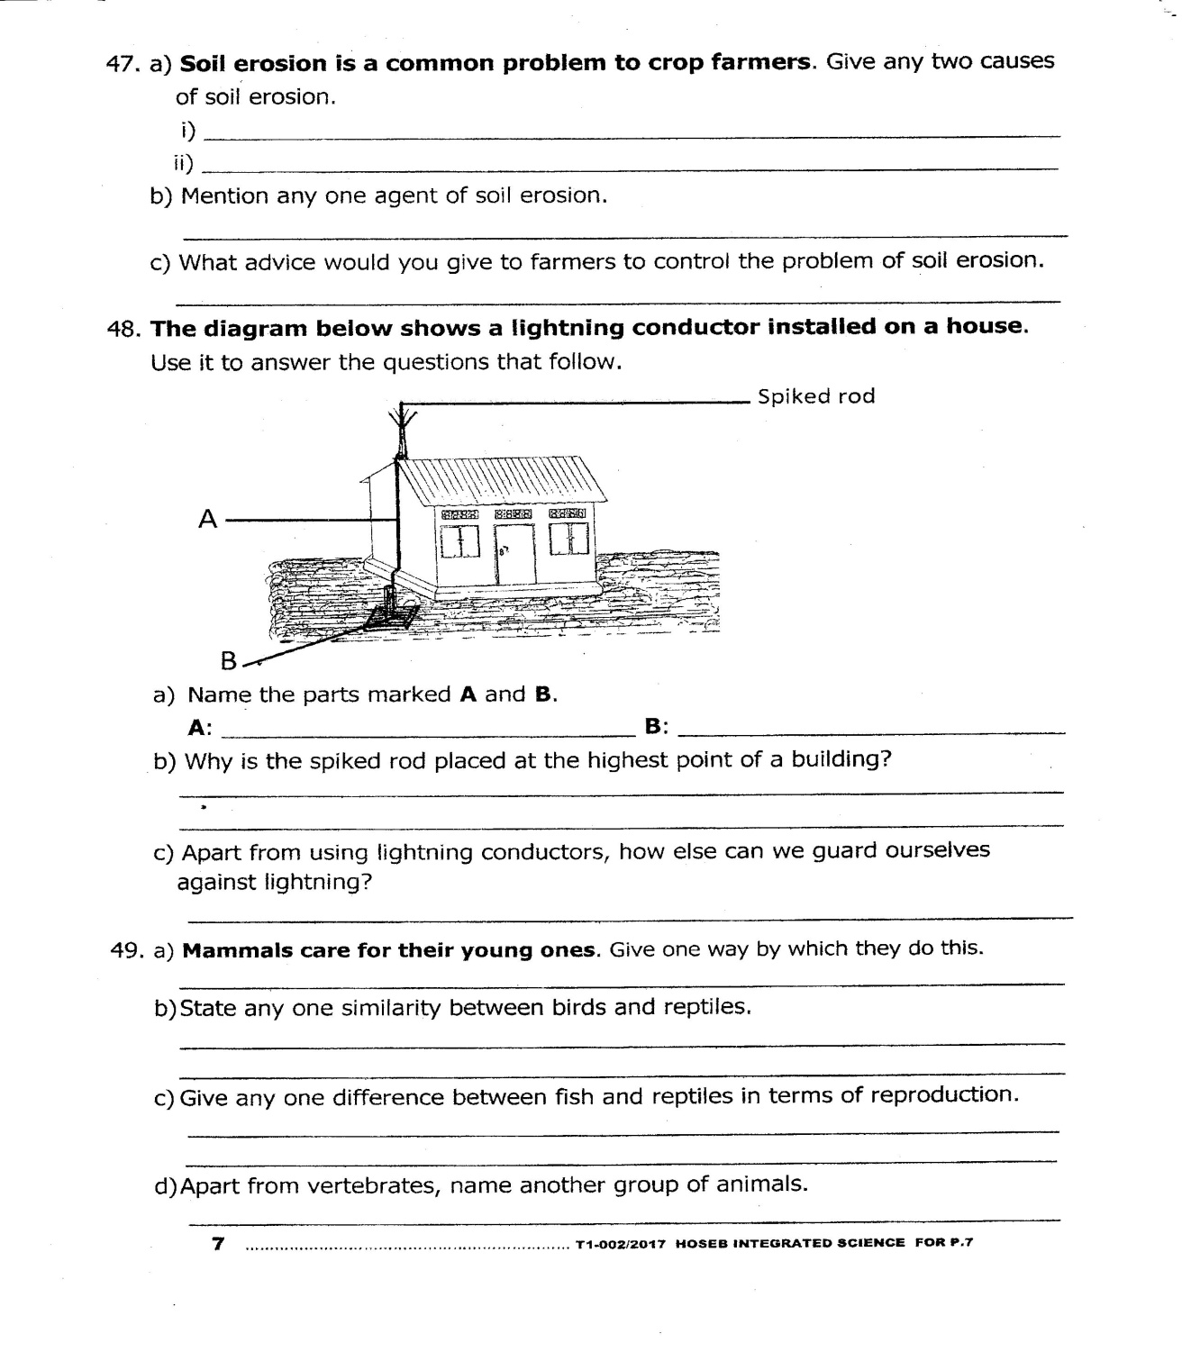

1. Name the parts marked A and B.

A: ………………..………………………………………….. B: ………………………………………………………………

1. Why is the spiked rod placed at the highest point of a building?

………………………..……………………………………………………………..……………………………………………..

1. Apart from using lightning conductors, how else can we guard ourselves against lightning?

………………………..……………………………………………………………..……………………………………………..

1. **a) Mammals care for their young ones.** Give one way by which they do this.

……………………………..……………………………………………………………..……………………………………………..

b) State any one similarity between birds and reptiles.

……………………………..……………………………………………………………..……………………………………………..

c) Give any one difference between fish and reptiles in terms of reproduction.

……………………………..……………………………………………………………..……………………………………………..

d) Apart from vertebrates, name another group of animals.

……………………………..……………………………………………………………..……………………………………………..

1. a) Write PHC in full.

……………………………..……………………………………………………………..……………………………………………..

b) List any two elements of PHC.

i) …………………………..……………………………………………………………..……………………………………………..

ii) ………………………..……………………………………………………………..……………………………………………..

c) Suggest one way by which you can promote PHC.

……………………………..……………………………………………………………..……………………………………………..

1. Use the organism drawn below to answer the given questions.

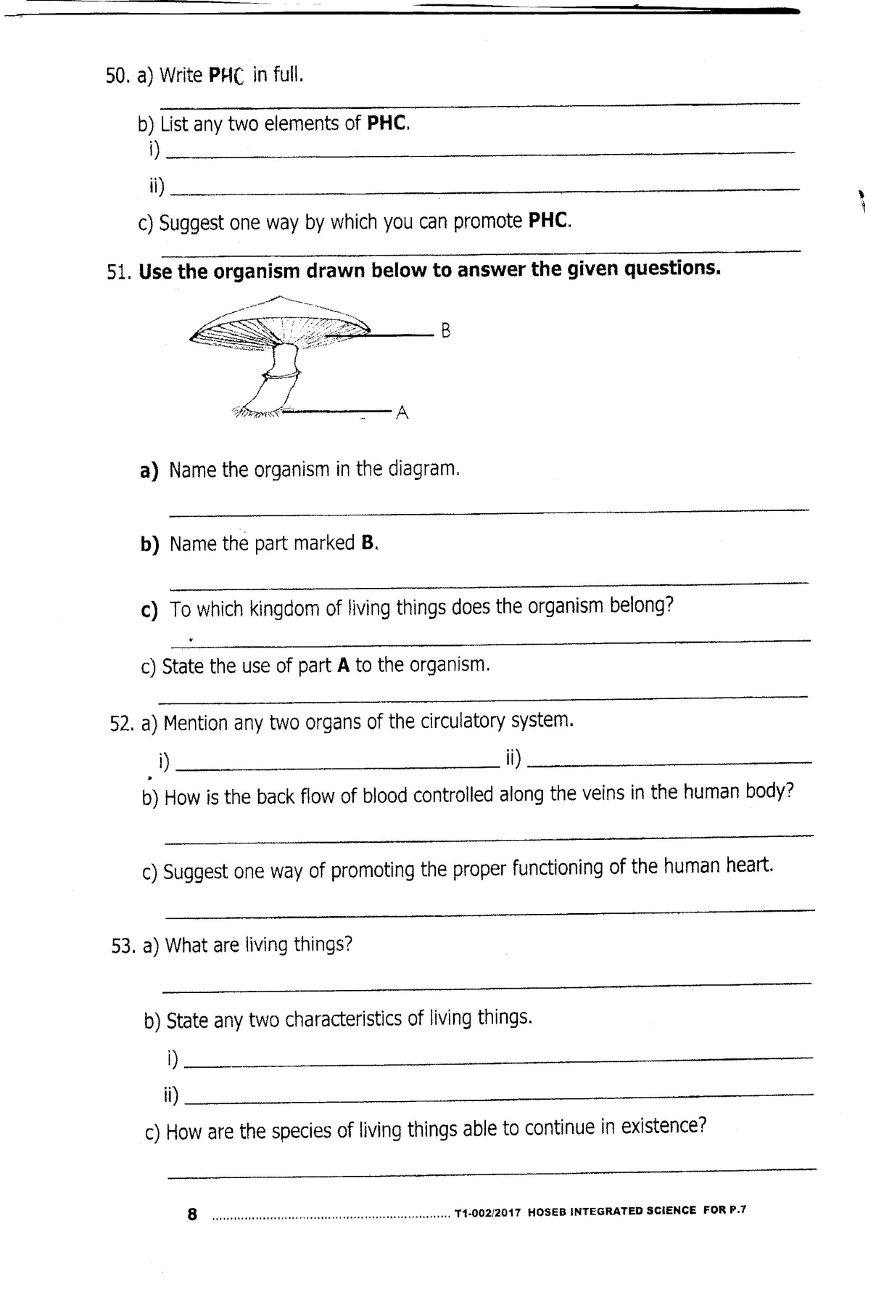

a) Name the organism in the diagram.

……………………………..……………………………………………………………..……………………………………………..

b) Name the part marked B.

……………………………..……………………………………………………………..……………………………………………..

c) To which kingdom of living things does the organism belong?

……………………………..……………………………………………………………..……………………………………………..

1. State theuse of part A to the organism.

……………………………..……………………………………………………………..……………………………………………..

1. a) Mention any two organs of the circulatory system.

i) …………………………………………………………….. ii) ……………………………………………………………………

b) How is the back flow of blood controlled along the veins in the human body?

……………………………..……………………………………………………………..……………………………………………..

c) Suggest one way of promoting the proper functioning of the human heart.

……………………………..……………………………………………………………..……………………………………………..

1. a) What are living things?

……………………………..……………………………………………………………..……………………………………………..

b) State any two characteristics of living things.

i) …………………………………………………………….. ii) …………………………………………………………………….

c) How are the species of living things able to continue in existence?

……………………………..……………………………………………………………..……………………………………………..

1. Two P.5 students set up solar driers as shown below to sun dry their harvested cereals. Use the diagram to answer the given questions.

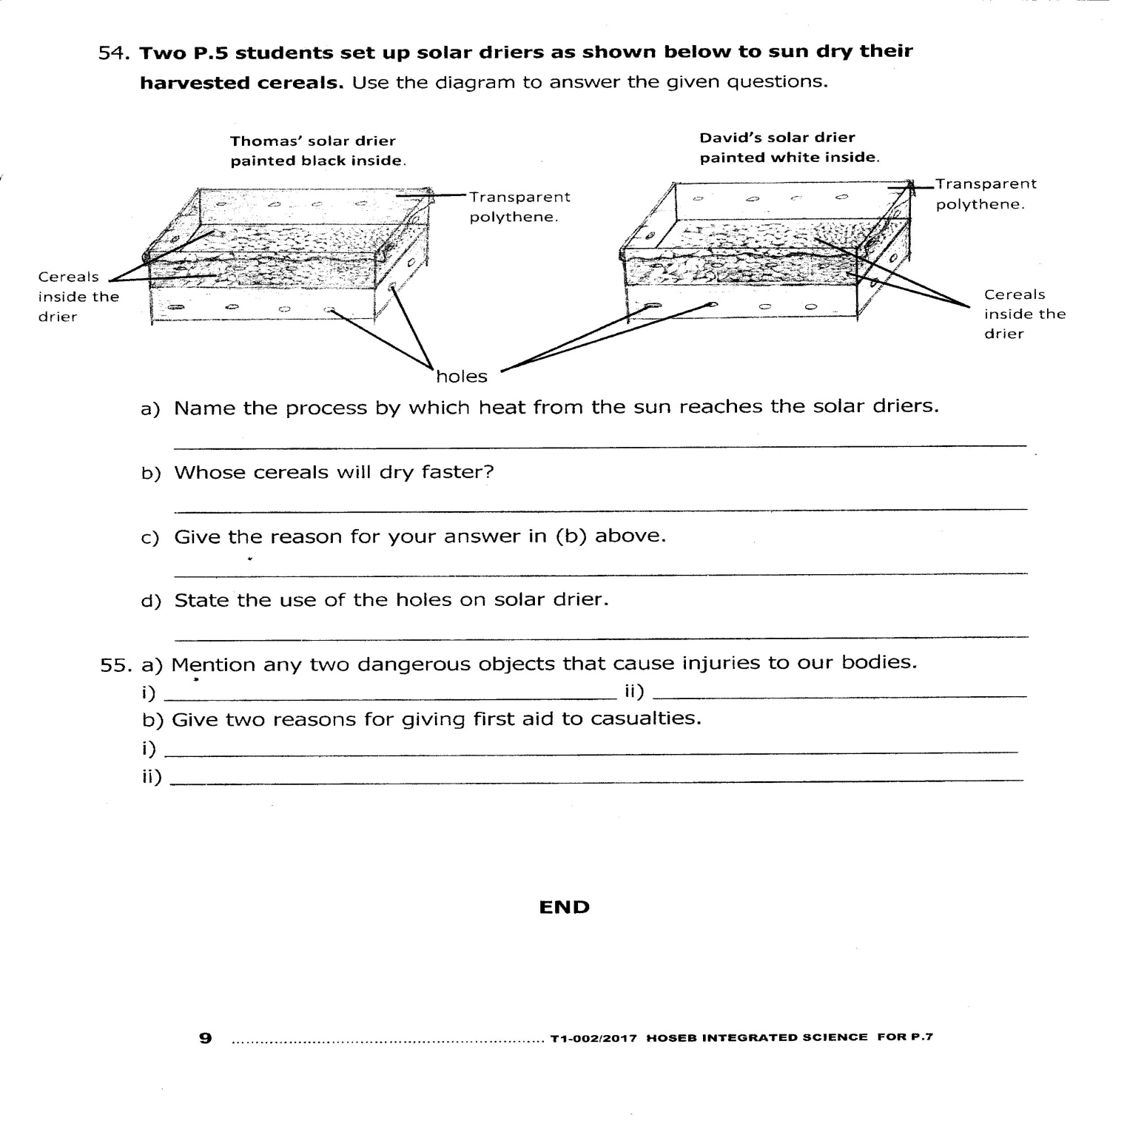

1. Name the process by which heat from the sun reaches the solar driers.

………………………..……………………………………………………………..……………………………………………..

1. Whose cereals will dry faster?

………………………..……………………………………………………………..……………………………………………..

1. Give the reason for your answer in (b) above.

………………………..……………………………………………………………..……………………………………………..

1. State the use of the holes on solar drier.

………………………..……………………………………………………………..……………………………………………..

1. a) Mention any two dangerous objects that cause injuries to our bodies.

i) ……………………………………………………………….. ii) …………………………………………………………………

b) Give two reasons for giving first aid to casualties.

i) ………………..……………..………………………………………………………..……………………………………………..

ii) ………………….……..……………………………………………………………..……………………………………………..

***“GOOD LUCK”***